**PYTHON ASSIGNMENT 1**

Submitted By – Ishita Bhatt

Sap Id – 590016198

**Part 1**

Question 1 : write a python scripts that print your name, course name, and the python version you are using also execute the script from the command line and include a screenshot of the output

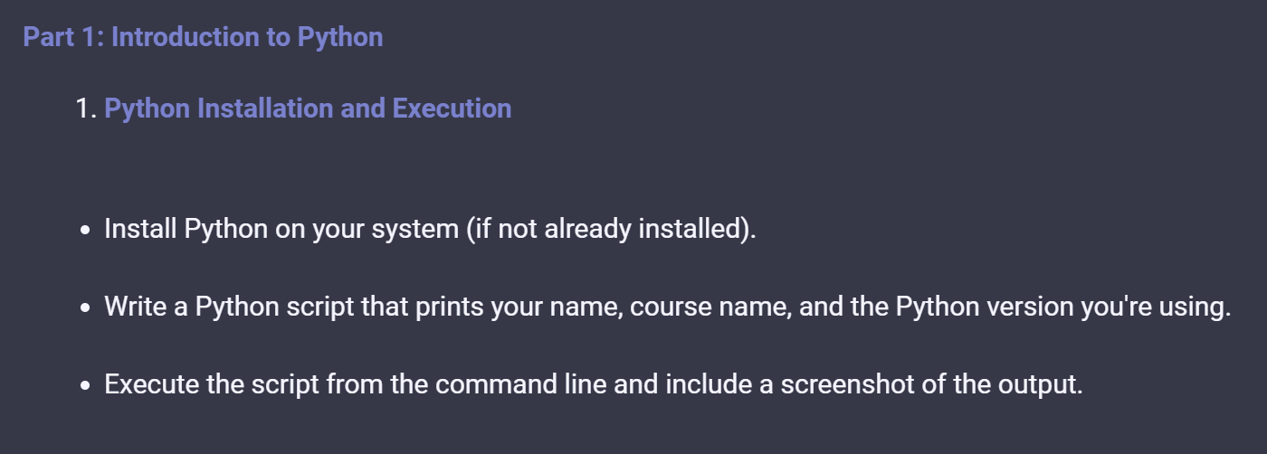

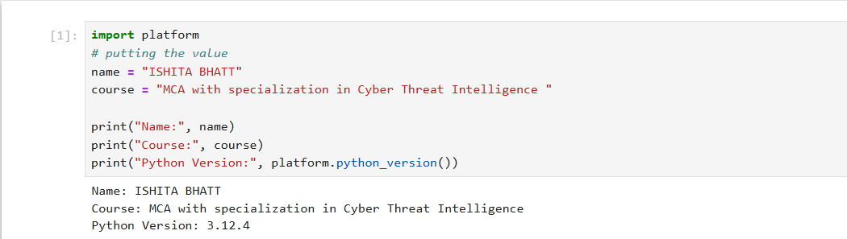

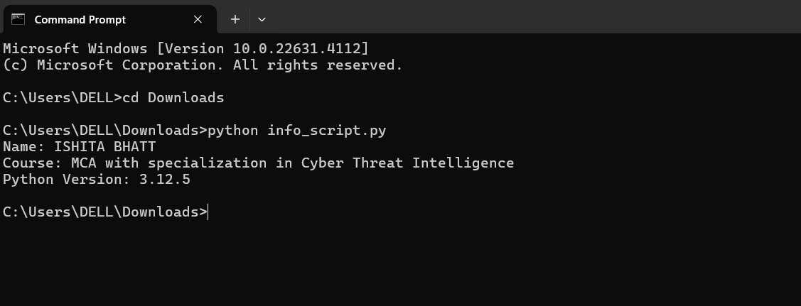

**Part 1->> Question 2**

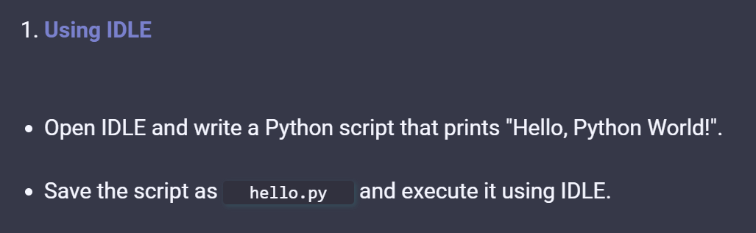

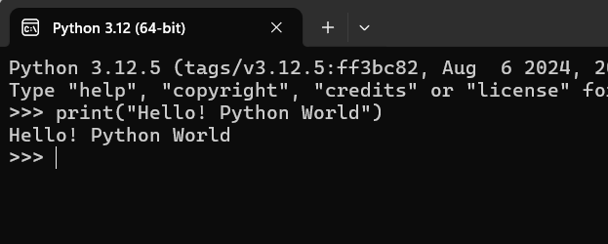

**Part 2 : Basic python Syntax**

**1 . String Operations**

**Question : Write a python program that takes user first name and last name as input and print them in reverse order with a space between them**

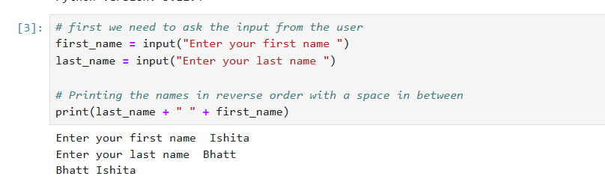

**Question : Use at least two string methods and explain their purpose in the comments in python**

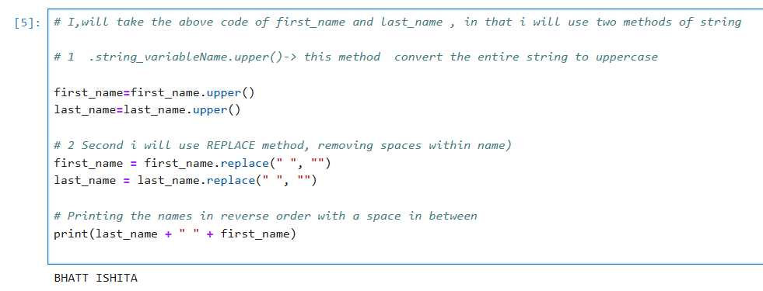

**2 .Numeric data type and Conversion functions**

**Question 1 : Write a python program that takes an input numbers from the users, convert it to different numeric data types(integers,float,and complex),and displays the converted values**

**Question 2: Also explain the difference between these data types in comments**

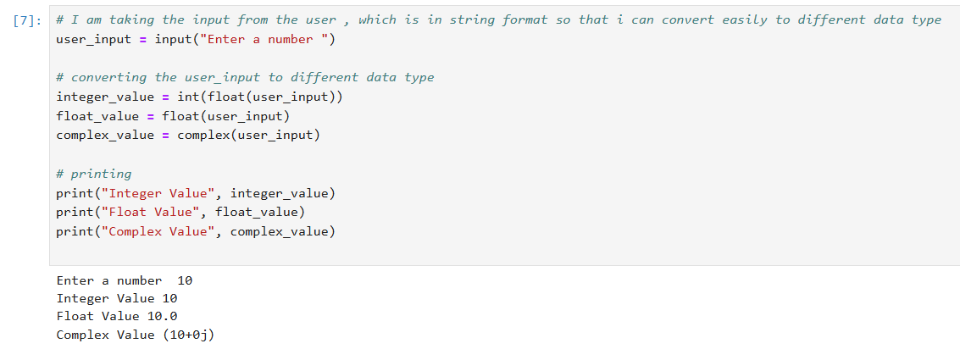

**Explanation of data types:**

**Integer**: Represents whole numbers without a fractional component, e.g., 5, -3, 42. In this program, the input is converted to an integer by discarding any fractional part.

**Float**: Represents numbers with a decimal point (fractional component), e.g., 3.14, -0.001, 2.0.The input is directly converted to a float to retain any decimal part.

**Complex**: Represents numbers in the form of a + bj, where 'a' is the real part and 'b' is the imaginary part.The input is converted to a complex number, where the imaginary part is set to 0 if not provided. For example, entering "3" will result in a complex number 3+0j.

**Question 3**

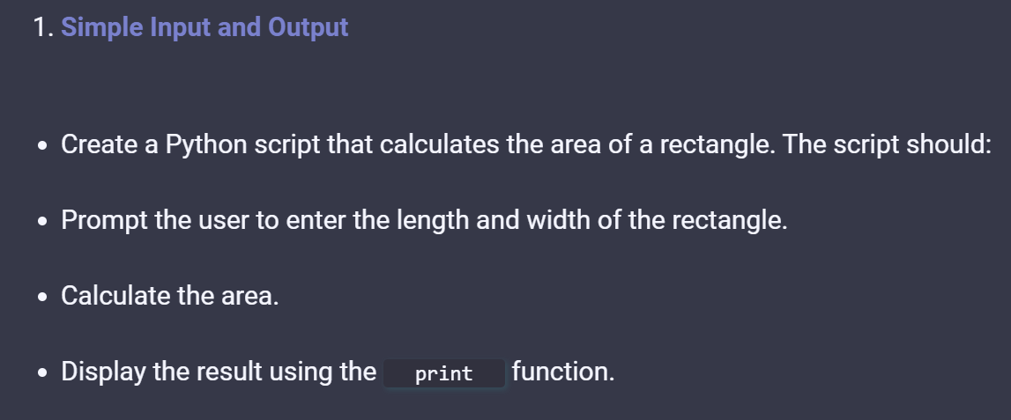

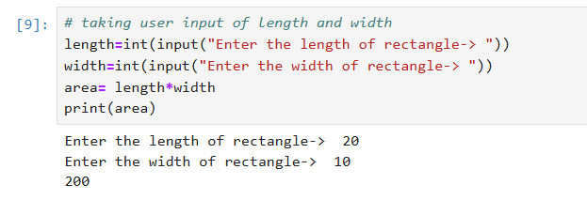

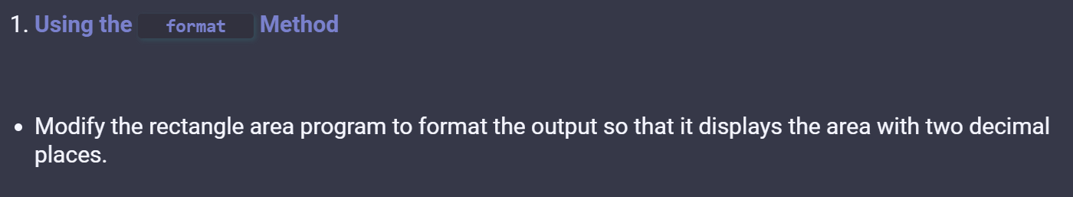

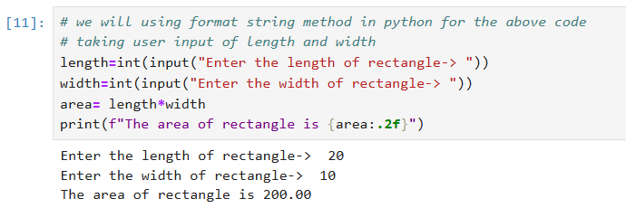

**part 2: Question 3**

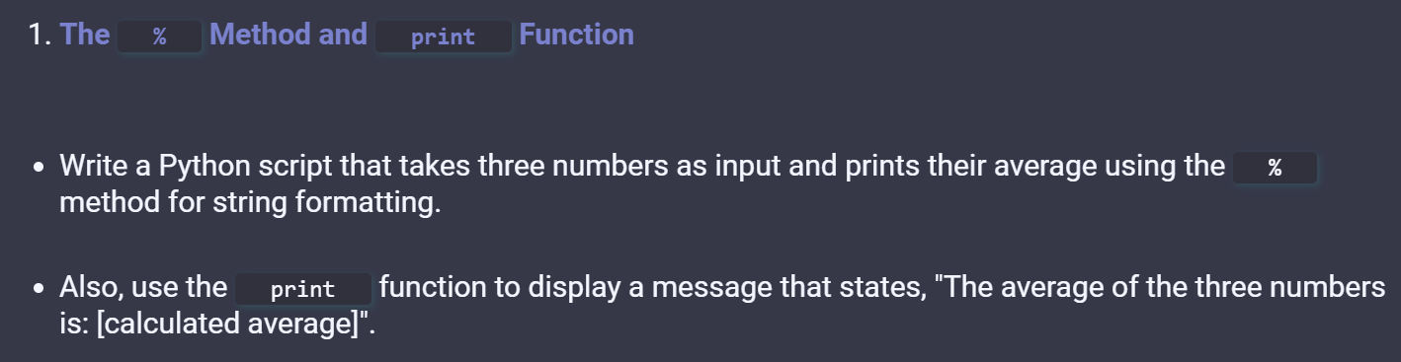

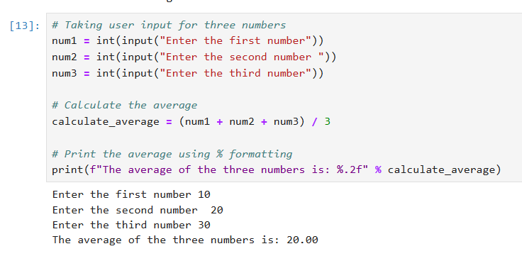

**Part 3 : Language Components**

Write a python program that ask the user for a number and determine whether it is postive,negative or zero

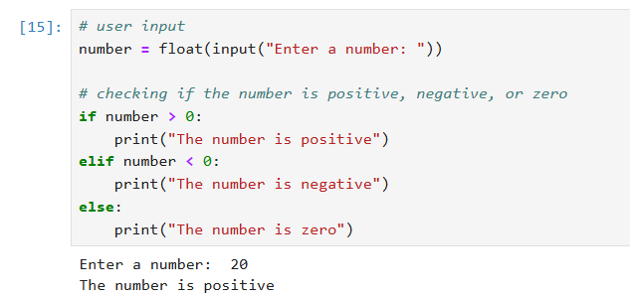

Implement a loop that continues to ask the user for a number until they enter exit

use break to exit the loop and continue to prompt for a new number if the input is not exits

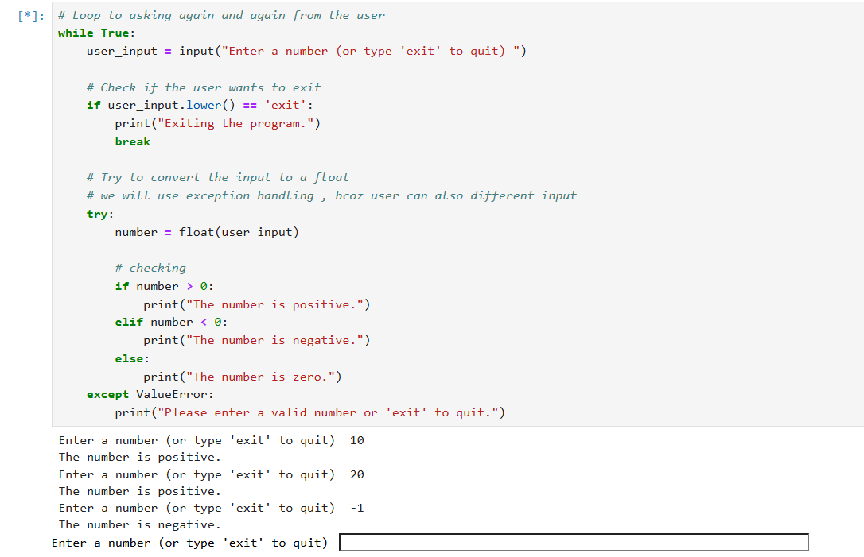

**Part 3 : Question 1 Relational and logical operators**

Create a python script that takes two number as input and print whether both numbers are even or odd or one of each using relational and logical operators

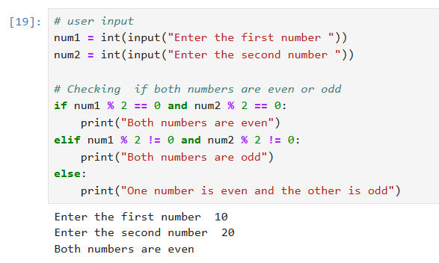

**For loop and bitwise operators**

